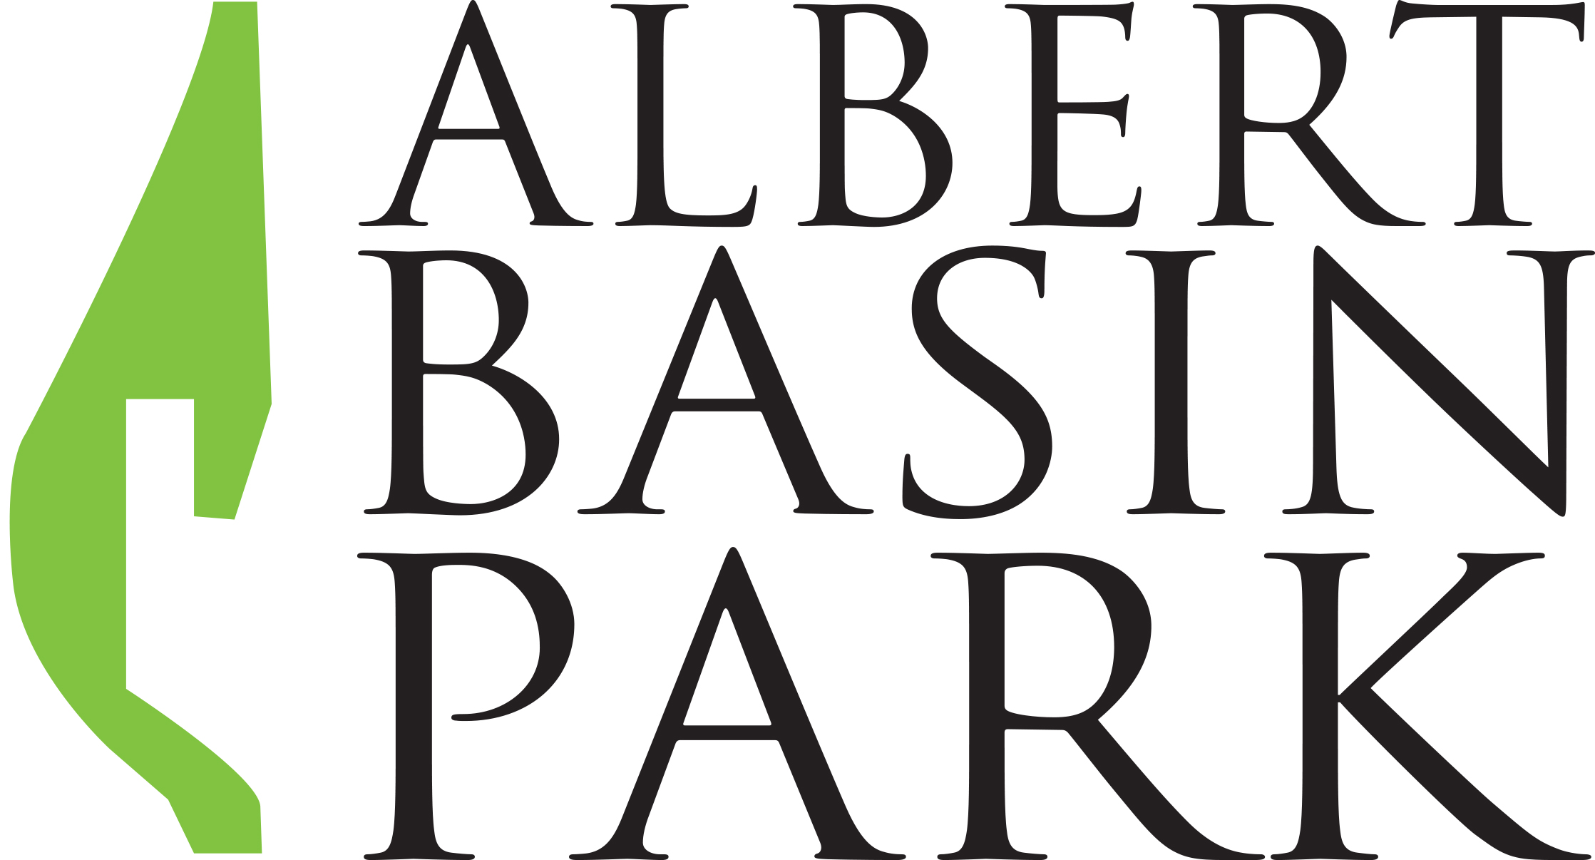

Albert Basin Park Project Endorsement Letter

We(Add Community Group Name),

support the proposal that the Albert Basin should be developed as a 15 acre city park for Newry.

We also give permission for our name and logo to be used as part of the Albert Basin Park Project campaign.

Yours Faithfully,

(Sign & Date)
________________________________________________________

on behalf of (Add Community Group Name)

